WAS YOUR
INFORMATION FOUND ON DARK WEB?
The Dark Web, which is usually considered as the misinterpreted part of online network is now a mysterious yet interesting topic that is attracting users worldwide as it is connected to occurrence of illegal pursuits online for example business related to theft of personal data, drugs and many others. It is necessary to look into the risks imposed by dark web, especially related to unethical misuse of someone’s personal data. Since billions of users are using internet worldwide, a very large number of subtle personal data is gathered, saved and used as part of a deal. So the motive behind this research is to dig into the process of exposure of data on the dark web to get an answer of “Was your information found on dark web?”
The clear motive is to interpret the scale, scope and process behind the disclosure of personal information of online users on this part of web i.e., dark web. With the help of analytical study of recent data exposures, leak incidents, and accessing tools, the research concludes to the general types of information and tracked on dark web marketplaces.
Cybercriminals primly target the personal data of cyber victims in the form of email ids, passwords, financial data, social security numbers, usernames and medical records because these information makes it much easier for them in procedure of identity theft, frauds and other venomous activities. Through these occurrence, the research focuses on main aspects of extraction of personal information from businesses as well as individual users which is shared on this platform known as dark web.
In order to collect the data, combine primary as well as secondary data is used. Collect primary data through case studies, interviews with the security experts and search tools available to track and recognize the personal data that may have been extracted. Some popular services are also evaluated with the help of this research such as “Have I Been Pwned” and “Dark Web Monitoring” services that can be used by end users to know whether their personal data is exposed on the dark web. This research also investigates the risks imposed to businesses as well as users at the time when their information is misused on dark web. The growth of illegal activities online raises issues regarding security of information and privacy in today’s world needs attention because these risks are related to the users across all existing domains whether its professional, government or social.
Consequently, this research provides a wide view of the present situation of cybersecurity in the domain of dark web and also recommends actions to be made in order to overcome risks. So the research says that although the dark web monitoring tools are helpful but still it may not be possible for it to cater the risk always so we can say it’s not full proof so some extra layers of security protections are needed to firmly protect the sensitive as well as personal data or info.
Through taking forward this serious question of if personal info of individuals is exposed on dark web, this project targets to spread awareness and build understanding of such critical digital issues that exist in today’s world by providing the right knowledge and measures that one may take to secure one’s personal data.

Lesson 1: Introduction

Background of the study:
The manner of living, communication and even the way of accessing any information has been transformed completely by the internet. Now people are much relied on online(digital) services for work, communication, socialising, lifestyle, mode of entertainment making internet a place holding huge number of sensitive and private data of individuals. Not only it holds the data, but the data can be accessed, stored, exchanged. But it also has its adverse effects which can harm individuals in many ways. There is an inherent risk to very own personal data of internet users as this data can be stolen, exposed and misused. That is why cybercrime has become major concern worldwide, that is extremely harmful. These cybercrime practices may include financial frauds, identity theft as well as data breaches which can cause complications to all existing domains.
The term “dark web” has become similar to the terms used to denote illegal digital activities as well as cybercrime in last 25 years. Dark web is nothing but an integral part of deep web which is the huge section of the internet but it cannot be indexed by existing traditional legal search engines. Dark web needs a special software to be accessed, for example Tor (The Onion Router). It is completely different from surface web which can be easily accessed using traditional search engines such as google chrome and Firefox. Tor software enables the individual to browse without revealing identity i.e., anonymously, making it a platform which is popular for different activities including the ones which are illegal to perform and are termed as malicious. The most disrupting activity can be classified as the activities on dark web related to trade of stolen identity (personal information), which also includes details of bank accounts, passwords and other login credentials, medical records, even government secrets which may be related to security concern of a country.
Personal data is the most important measure of digital interactions. In order to grant the access a vast variety of online services, that personal and sensitive data of individual is used in the form of emails, usernames and credit card numbers etc to personal info security. Unluckily this is the most targeted data and set of information by cybercriminals, who can access it illegally by various practices namely hacking, phishing, data breaches and social engineering attacks. Once stolen, this set of data is easily traded or exchanged on marketplaces of dark web, where it is utilised in order to commit fraud, help and facilitate identity theft or allow more sophisticated criminal activities.
In last few years, it is recorded that there is a major rise in the cases of breaches of data as well as the leaks across digital industries. 2017 Equifax breach was one of the high profile incidents, where the personal data of approx. 145 million users was exposed. Also the Twitter 2020 attack, which lead to the compromise of the accounts or handles belonging to public personalities, flashing light on the vulnerabilities in both private as well as government sectors. These breaches and the availability of personal data on the dark web subsequently, cater the needs of users to realize and gain knowledge about the risks related to the exposure of data. As data leakage has become common part of society, the requirement to have effective monitoring equipments and strategies to protect the personal information has increased. Services like “Have I been pwned?” allows the user to look after if their passwords and email addresses have been a part of data breach. Inspite of having such tools, many users still remain unaware of the fact that how their personal data is misused after being stolen or where will the data be exposed in future? In this project, we will study about the concerns by exploring the level to which personal information of individuals is exposed on dark web, the procedure through which the info reaches there and the risks related to that exposure.

Problem Statement
The internet providing a drastic revolution in the way of living of people, way of working, as well as interacting with one another. The huge adaptation of internet and mobile technologies has changed every aspect of life, from communication to business or commerce to entertainment. But the increased faith in digital technologies has also created a sword that has edges on both the sides- first where it makes it convenient in modern life by risking privacy, security and personal safety.
In the contemporary digital landscape, one of the most reminding threats is the misuse of personal information on dark web. The dark web is a hidden part of the internet accessed with special software like the Tor browser, which provides user anonymity and bypasses censorship. Even after being associated with the illicit activities, the dark web is not inherently illegal. However, its unregulated nature and anonymity have made it a better place for criminal enterprises, which also includes the trade of stolen personal data, illegal goods and other illicit activities. Personal data such as social security numbers, bank account details, credit card numbers, login credentials, and medical records may be bought and sold on various dark web marketplaces. .
Cybercriminals really value this kind of info, who utilise it to perpetrate financial fraud, identity theft, hacking, and various other forms of cybercrime. Because it can result in immediate financial loss, harm to one's reputation, or more serious outcomes like identity theft and privacy violations, the presence of personal information on these underground marketplaces poses a serious risk to people, businesses, and even whole countries.
Most internet users are still ignorant of how much of their personal information is available on the dark web, even in spite of the rising number of well-publicized data breaches and hacks. They might not be aware of if or how their data has been compromised. Accessed, or the dangers of being exposed to it. When personal information is compromised, it frequently ends up on dark web marketplaces where it is traded, sold, or used for other illegal purposes. Before they become victims of fraud, identity theft, or other cybercrimes, people might not even be aware that their data is moving through these underground markets. Despite the rising number of notable data breaches and cyberattacks, many internet users are largely unaware of how much of their personal information is available on the dark web. They often do not know if their data has been compromised, how it was accessed, or the potential dangers of its exposure. When personal data is breached, it frequently ends up on dark web marketplaces, where it can be traded, sold, or used for further criminal activities. Many people are unaware their data is being sold on the dark web until they become victims of fraud or identity theft. Modern data breaches make this problem worse. Cybercriminals use various advanced methods to obtain sensitive information, such as phishing, ransomware, malware, social engineering, and direct hacking. The vast scale and frequency of these breaches—often involving millions of records—make it increasingly challenging for individuals and organizations to monitor their exposure. Large organizations and service providers often experience data breaches that compromise significant amounts of personal information, increasing the likelihood that many internet users will be affected. Some breaches result in data being available on the dark web within hours, ready for purchase by the highest bidder. Additionally, the lack of immediate awareness or real-time alerts means individuals often remain oblivious to when their personal data has been compromised. Without effective monitoring tools or systems, they are left exposed to the risks of identity theft, financial loss, and fraud. While some platforms, like “Have I Been Pwned,” allow users to check if their email addresses or passwords have been involved in known breaches, many people are not aware of these services. Even when they are, these tools cannot thoroughly monitor all dark web marketplaces and data exchange sites where stolen information might appear. This creates a significant gap in protecting personal information.
Personal data exposure on the dark web poses complex risks, leading to both immediate losses and long-term effects.

The Research Problem:
This study aims to identify how often personal data appears on the dark web, examine the techniques used for obtaining and sharing this data, and assess the potential risks related to such exposure.
This study aims to address the following questions:

- Personal information is sometimes exposed on the dark web, where data may be traded on various online platforms. It remains uncertain which specific types of personal information are most frequently disclosed or used. This research aims to identify recurring patterns and trends in the categories of data found on dark web sites.
- Personal data can appear on the dark web due to theft or hacking. Knowing how this happens helps reveal the scope of the issue. The study will analyze the main sources of data exposure, such as cyberattacks, data breaches, phishing and social engineering tactics, and assess how these methods lead to the sharing of personal data on the dark web.
- What are the risks and consequences of exposing personal data on the dark web?
The dark web poses major risks; compromised personal data can lead to identity theft, financial fraud, and targeted attacks. This research will explore the short- and long-term consequences of selling, trading, or using personal information on the dark web.
- Which tools and services are available for monitoring and safeguarding personal data against exposure on the dark web? Numerous solutions have been developed to assist both individuals and organizations in overseeing their personal information online, including platforms that conduct scans of dark web marketplaces. This study will examine the effectiveness of these tools in alerting users to data exposure and assess the limitations and challenges of using these services.
- What measures can individuals and organizations take to reduce the likelihood of data exposure on the dark web? This research offers guidance based on the findings to help both groups safeguard their information. This will include adopting stricter cybersecurity practices, using data encryption, enabling multi-factor authentication, and using dark web monitoring tools to track potential breaches.

Objectives
- To examine the categories of personal information available on the dark web.
- Understanding how breach data appears on the dark web.
- To identify the risks and implications of having personal information on the dark web.
- Explore tools and techniques for monitoring and protecting personal data.
- Propose recommendations to reduce exposure and strengthen cybersecurity measures.

Lesson 2: Review of literature

The Dark Web is a widely debated and often misunderstood part of today’s Internet. Often depicted in popular media as a heaven for criminal activity, the Dark Web is a complex and layered area within the larger Deep Web that remains largely inaccessible through mainstream Internet browsers. This section explains what the Dark Web is, its structure, main features, and how it contrasts with the Surface Web and Deep Web, as well as their impact on privacy, security, and cybercrime.

Definition of the Dark Web:
In order to comprehend the Dark Web, it is crucial to differentiate among the three primary segments of the Internet: the Surface Web, the Deep Web, and the Dark Web. The Surface Web refers to the portion of the Internet that is indexed by standard search engines such as Google, Bing, and Yahoo. This is the part of the web that most people use regularly. Surface websites are easily discovered and accessible by anyone with an Internet connection.
Deep Web: The Deep Web encompasses internet content that is not indexed by conventional search engines. This includes password-protected websites, databases, subscription-based services, private cloud storage, and any web content that is not intended to be publicly accessible. While the Deep Web comprises most of the content available on the Internet, not all of it is illegal or harmful. In fact, much of this content consists of personal, academic, and professional content that is securely stored and accessed with specific authorization.
Dark Web: The Dark Web is a subset of the Deep Web, accessible only with special software like Tor. It is hidden from standard search engines, offering anonymity by routing traffic through multiple servers. This privacy has contributed to its association with illegal activities.
The Dark Web is a decentralized network with content on ".onion" domains, accessible only via Tor or similar browsers. While often linked to crime, it is not illegal itself and serves legitimate purposes like anonymous communication, protecting privacy, and supporting free expression under oppressive regimes.

Features of the Dark Web:
The Dark Web has several defining characteristics that distinguish it from the Surface Web and the Deep Web:
- Anonymity: The Dark Web enables users to remain fully anonymous. The Tor network uses layered encryption and routes traffic through volunteer-run relays, making it hard to trace users' identities or locations and offering greater privacy than the surface web.
- Decentralization: The Dark Web operates in a decentralized manner. Unlike centralized services on the surface web, such as Google or Facebook, dark web services do not rely on a single server or entity. Instead, they are hosted on a distributed network of servers that only specific software like Tor can access. This decentralization contributes to the difficulty of shutting down or controlling Dark Web activity.
- Hidden Services: Dark Web sites commonly use “.onion” domains, which are accessible via the Tor browser. These websites are usually “hidden services,” meaning that their IP addresses and physical locations are hidden to preserve anonymity. Unlike the surface web, where sites are easily identified and traced to a physical server or host, the opposite is true elsewhere.
- Cryptocurrency Use: Dark Web transactions typically use cryptocurrencies like Bitcoin or Monero for anonymity. These digital currencies enable transactions without the disclosure of personal or financial information by users. Cryptocurrencies are increasingly being used to purchase illegal goods and services on the Dark Web, such as stolen data, drugs, weapons, and hacking tools.
- Restricted Access: Unlike the surface web, which can be accessed with any conventional browser, the Dark Web requires specific access methods. The most widely used tool is Tor, but other networks and privacy tools, such as I2P (Invisible Internet Project) or Freenet, are also used to access Dark Web content.
- High Risk of Illegal Activities: The Dark Web, which prioritises anonymity and operates without regulation, frequently hosts illegal activities.
Data Breach and Its Impact:
In the current digital environment, data breaches have emerged as a prevalent and escalating concern for individuals, organizations, and governmental entities. A data breach takes place when individuals without authorization access sensitive or confidential information. The impact of these breaches is profound, as they can result in a wide range of financial, personal, and organizational consequences. Data breaches not only undermine privacy and security, but can also disrupt operations, damage reputations, and expose individuals to various forms of cybercrime, especially when compromised information ends up on the dark web.
This section covers types of data breaches, how personal data is compromised, their legal and financial impacts, and broader effects on privacy and cybersecurity.
Particular attention will be paid to the impact of data breaches on the dark web, where stolen information is often sold, traded, or exploited by cybercriminals.

Definition of Data Breaches:
A data breach happens when personal, financial, or confidential information is access or shared without permission. Such breaches may arise from a range of sources, including cyberattacks, insider threats, inadvertent disclosures, or the physical theft of devices.
Data breaches may involve the compromise of information ranging from basic identifiers, such as names and email addresses, to highly sensitive records including social security numbers, financial details, login credentials, and medical data. The nature of the data compromised dictates the severity of the breach and the potential risks to those affected. Some breaches may be a relatively minor inconvenience, while others expose individuals to significant financial loss, identity theft, or fraud. Data breaches are classified by the type of data involved and the means of exposure. The most common types of breaches are:
- Hacking and cyberattacks: The most common form of data breach, which involves unauthorized access to networks or systems through techniques such as phishing, malware, ransomware, or brute force attacks. Hackers exploit
weaknesses in an organization’s security infrastructure to steal sensitive data.
- Insider Threats: In some cases, contractors or employees with authorized accessed data may misuse it knowingly or unknowingly, potentially leading to a breach. Insider threats can include the theft of intellectual property, customer data, or other confidential information.
- Physical data Theft or Loss: Data breaches is arrived when physical devices, such as laptops, hard drives, or USB drives that contain sensitive data, are stolen or lost. If devices are not properly encrypted or secured, data can be easily accessed.
- Accidental Disclosure: Sometimes data breaches are caused by human error, such as accidentally sending email which contain sensitive information to wrong recipient or exposing a database to the public Internet without adequate security measures.
The Dark Web and Data Breaches:
One of the most concerning aspects of data breaches today is the exposure of stolen information on the Dark Web. The Dark Web is a hidden part of the Internet that is not indexed by traditional search engines and can only be accessed using specialized browsers such as Tor. Dark web is often associated with illegal activities, including sales and exchange of stolen personal data. After the theft of data after a violation, cyber criminals often return to the dark web to trade or sell it. Data sold on the dark web may include sensitive information such as:
- Login credentials: Usernames, passwords, and email addresses obtained through breaches can be used to access individuals’ accounts or sold to others for exploitation.
- Financial data: Credit card numbers, bank details, and payment information are highly sought after on the dark web, where they are used for fraudulent transactions or sold to other criminals.
- Personally identifiable information: Social security numbers, birth dates, addresses, and other PII can be used for identity theft, opening fraudulent accounts, or tax fraud.
- Medical devices: Medical records and other personal health information and data is sell on the dark web to fraudsters who can use them to obtain prescriptions or sell them to companies for fraudulent billing or marketing purposes.
- Intellectual property: In some cases, data breaches involve the theft of corporate intellectual property, trade secrets, or research, which can be sold to competitors or used for espionage.
For cybercriminals, the dark web provides a relatively anonymous and unregulated platform to conduct illegal transactions. The anonymity of the dark web, combined with the use of cryptocurrencies for payments, allows criminals to avoid detection and prosecution.

Consequences of data breaches:
The effects of a data breach can spread widely, causing problems for the companies involved as well as the people whose information was stolen. How serious the situation is depends on factors like the kind of data that was accessed, how much was affected, and how fast the issue was found and handled. The main outcomes of a data breach typically include:
- Financial impacts.
- Privacy violations.
- Reputational damage.
- Legal and regulatory consequences.

Preventing and responding to data breaches:
- Encryption.
- Employee training.
- Regular security audits.
- Multi-factor authentication.

Trading of information on dark web:
The Process of Sharing Information on the Dark Web:

Trading stolen information on the Dark Web generally follows a well-defined process, although the specific methods may vary depend upon the type of information being exchanged. The general flow of the information exchange includes the following steps:
- Receipt of stolen data: Data is usually obtained through hacking, data breaches, phishing campaigns, or physical theft of devices. Cybercriminals can also exploit poor security practices or vulnerabilities in organizations and IT systems to steal sensitive information. For example, they can use malware to infiltrate a network, steal data, and discover it on external servers.
- SEO in the market: Once the data is obtained, it is often put up for sale on the dark web and underground markets. These marketplaces are specifically designed to facilitate the buying and selling of illegal goods, including stolen data. Sellers usually provide details about the data, such as the type of information, the number of records, and the method of receipt. In some cases, the information and data is sell in bulk, make it easy for criminals to target a large number of individuals or organizations.
- Transaction Process: Transactions in the dark web is done through cryptocurrencies (e.g. Bitcoin, Monero), as they allow for anonymity and privacy. Cryptocurrencies are typically used to prevent the identity of the buyer and seller from being revealed, ensuring that law enforcement or financial institutions cannot track the flow of funds. o In some cases, buyers may choose to pay using escrow services, where the cryptocurrency is held in an intermediary account until the buyer confirms receipt of the information. If the buyer confirms that the details are as described, the funds are released to the seller.
- How it works: After the transaction is complete, the buyer can use the stolen data for a variety of purposes. This can include identity theft, fraud, extortion, industrial espionage, or even selling the data to other criminals. The information or data is also used for a larger cyberattack or cyberwar, such as ransomware campaigns, phishing, or a data breach.
- Anonymity and Security: Anonymity is essential for both the buyer and the seller, as the illegal nature of the transactions makes them vulnerable to detection by law enforcement. To protect their identities, both parties typically use encrypted communication methods, such as encrypted emails or secure messaging services. Using VPNs (Virtual Private Networks) and Tor browsers makes their activities even more anonymous.

Dark Web Markets and Platforms:
Dark Web markets serve as digital bazaars where cybercriminals can buy and sell stolen data and other illegal goods. These markets are decentralized and generally operate without government oversight, allowing them to operate beyond the reach of law enforcement. Some of the most prominent dark web marketplaces where information is exchanged include:
- AlphaBay (now seized): AlphaBay was one of the largest and most popular dark web marketplaces before it was taken over by law enforcement in 2017. It hosted a wide variety of illegal goods, including stolen data, drugs, and weapons.
- Dream Market (now seized): Dream Market was another large marketplace that facilitated the sale of stolen data and personal information. It was known for offering a variety of illegal goods and services, but like AlphaBay, it was eventually shut down by authorities.
- Empire Market: Empire Market was a well-known marketplace for buying and selling various illegal goods, including hacked accounts, credit card information, and stolen personal information. Although it was shut down, it was widely used by cybercriminals.
- Markets for hacking tools: In addition to platforms like AlphaBay, there are markets on the dark web that specialize in selling hacking tools, exploit kits, and other digital weapons used for data breaches and cyberattacks. These markets offer a wide range of services to cybercriminals looking to carry out attacks against organizations and individuals.
Despite law enforcement efforts to shut down these markets, new platforms continue to emerge. The decentralized nature of the dark web, coupled with the use of anonymity tools, makes it difficult to fully dismantle these illegal trading networks.

The impact of information trading on the dark web:
The trading of stolen information on the dark web has far-reaching consequences for individuals, businesses, and society at large:
- Financial Losses: Theft of financial data, such as credit card information and banking details, leads to direct financial losses for individuals and organizations. In addition, organizations can face financial penalties and legal action if they fail to adequately protect sensitive customer information.
- Identity Theft and Fraud: Personally Identifiable Information (PII)became other big marketplace that facilitated the sale of stolen data.

Monitoring tools for data breach of individuals:
- Have I been pwned?
- DeHashed
- IdentityForce 4. BreachAlarm
5. Credit Monitoring Services.

Data Breach Monitoring tools for Organizations:
- Dark web monitoring services.
- Risk management and threat intelligence platforms.
- Data loss prevention (DLP) systems.
- Endpoint detection and response (EDR) systems.
- Cloud Security posture management (CPSM) tools.

Cybersecurity measures to protect personal data:
In today’s digital age, where personal data is constantly being generated, stored, and transmitted across various platforms, protecting sensitive information from unauthorized access and misuse has become paramount. Cyberattacks, data breaches, and identity theft are pervasive threats to individuals, organizations, and even governments. As the frequency and sophistication of cyberattacks increase, robust cybersecurity measures are essential to safeguard personal data from malicious actors. This section provides an overview of various cybersecurity measures that can help protect personal data. These measures encompass a wide range of strategies, from basic security practices to advanced technological solutions, and are aimed at preventing unauthorized access, ensuring data integrity, and maintaining confidentiality. The chapter discusses the importance of cybersecurity hygiene, encryption, authentication techniques, threat detection, and awareness training, among other security practices.

General cybersecurity measures for protection of personal data:
- Strong passwords and password manager.
- Two-Factor Authentication.
- Regular Software Updates and Patch Management.
- Antivirus and Anti-Malware software.

Encryption and Data Protection Technologies:
Encryption is a fundamental cybersecurity technique used to protect data confidentiality and prevent unauthorized access. It involves transforming plaintext data into an unreadable format (cipher text) using an algorithm and a key. Only authorized users with the correct decryption key can revert the data back to its original form.
- End to End Encryption.
- Disk Encryption.
- Data Masking and Tokenization.
Advanced Authentication Mechanisms:
Strong authentication mechanisms are critical for ensuring that only authorized users can access personal data. Advanced authentication methods provide higher levels of security than traditional username-password combinations, particularly in an age where cybercriminals are adept at bypassing basic authentication protocols.
- Biometric Authentication.
- Behavioural Authentication.
- Multi-Factor Authentication.

Threat Detection and Incident Response:
In addition to preventative measures, organizations and individuals should have robust systems in place to detect potential threats and respond quickly to data breaches. Early detection and rapid incident response can minimize the impact of a breach and protect personal data from further exploitation.
- Intrusion Detection and Prevention Systems (IDPS): Intrusion Detection and Prevention Systems (IDPS) monitor network traffic for signs of suspicious activity or malicious behaviour. These systems use signature- based detection (identifying known threats) and anomaly-based detection (identifying deviations from normal behaviour) to flag potential intrusions. By identifying threats in real time, IDPS can alert security teams to potential data breaches or network compromises and prevent unauthorized access to sensitive data.
- Security Information and Event Management (SIEM): SIEM solutions collect and analyse data from various security systems within an organization, providing centralized visibility into security events and incidents. SIEM platforms use advanced analytics and machine learning to detect patterns of suspicious behaviour and generate alerts when an anomaly is detected. SIEM systems play a crucial role in incident detection, investigation, and response, providing a unified view of security incidents across multiple sources, such as firewalls, intrusion detection systems, and endpoint security software.
- Incident Response Plans: A well-documented and regularly reviewed incident response plan is essential to ensure that an organization or individual can respond quickly to a data breach or cyberattack. The plan should include specific steps to contain the breach, mitigate the damage, notify affected parties, and comply with legal and regulatory requirements. Incident Response Teams (IRTs) are formed to manage and respond to security incidents, and having a clear plan allows for a faster and more effective response when personal data is at risk.

Lesson 3: Research Methodology:

Data Collection:
Data collection is an essential part of any research project, as it forms the basis of analysis and supports the validation of research objectives. In this study, the focus is on investigating the presence of personal and sensitive information on the dark web and identifying cybersecurity measures that can help mitigate the risks associated with such exposure. The purpose of this research is to understand the current state of data breaches, how personal data is exploited on the dark web, and preventive measures that can be taken to protect sensitive information from misuse.
To achieve the research objectives, a multi-method approach was used for data collection, including qualitative and quantitative methods. This approach provides a comprehensive understanding of issues related to data breaches, dark web monitoring, and the effectiveness of various cybersecurity strategies. The main data collection methods in this study include:
- Secondary data collection (literature review and existing data)

- Primary data collection (surveys and interviews)

- Dark web monitoring (simulated exposure and analysis)

Each method will be explained in detail in the following sections, illustrating how they contribute to answering the research questions and achieving the study objectives.

Secondary data collection
Secondary data collection involves the collection of existing information from a variety of published sources, including academic journals, books, government reports, Internet articles, and industry reports. This method helps to establish a theoretical foundation for the research and provides context for the statement of the study problem. Objective of secondary data collection:
- Review the current literature on data breaches, dark web activities, and data protection measures.
- Collect existing statistics, case studies, and expert opinions on data exposure on the dark web.
- Understand the effectiveness of various cybersecurity measures and strategies that have been implemented by individuals, organizations, and governments.
- The secondary data collected will be used to:

- Develop a deeper understanding of the factors that contribute to a data breach
and how personal data is shared and exploited on the dark web.
- Analyse data breach trends and the financial, emotional, and social consequences of exposed personal data.
- Identify gaps in current cybersecurity measures and the need for better data monitoring and protection solutions. Secondary data sources will include:
- Peer-reviewed journals, such as those related to cybersecurity, data privacy, and information security.
- White papers and reports from cybersecurity companies, such as Symantec, McAfee, and IBM, that track data breaches and activities on the dark web.
- Official reports and publications from government agencies such as the U.S. Federal Trade Commission (FTC) or the European Union Agency for Cybersecurity (ENISA).
- Case studies of data breaches and incidents visible on the dark web.
This method of collecting secondary data will help contextualize the primary research and provide a theoretical framework for analysing the findings.

Primary Data Collection:
Primary data collection involves the direct collection of data from original sources. In this research, primary data will be collected using two main methods: surveys and interviews. Both approaches will provide insight into individuals’ experiences and opinions regarding data breaches and the use of cybersecurity measures.
A. Research Objective: Surveys will be conducted to collect quantitative data from a broad audience on individuals and their awareness of data breaches, their knowledge of cybersecurity measures, and their concerns about the exposure of personal data on the dark web. The survey will also collect data on respondents’ personal experiences with data breaches, such as whether they have ever had their data exposed on the dark web or been a victim of identity theft.
Survey Design: The survey will consist of a series of closed-ended, Likert-scale questions that will allow for easy statistical analysis. The questions will focus on:
- Respondents’ knowledge of data breaches and dark web activities.
- Experience of identity theft or data exposure.
- Use of cybersecurity measures (e.g., password managers, two-factor authentication).
- Concerns about personal data protection and trust in online platforms.
Target Population: The survey will target a wide demographic, including people of different ages, genders and occupations. A sample of at least 200 participants will be selected, ensuring the diversity and generalizability of the results.
Data analysis: After the surveys are completed, the data will be analysed with statistical software to identify trends and correlations. Descriptive statistics (such as the distribution of means, modes, and frequencies) will be used to summarize the data, and inferential statistics will be applied to draw conclusions about the population. B. Interview

Objective: Semi-structured interviews will be conducted with cybersecurity experts, including cybersecurity analysts, IT professionals, and individuals who have experienced data breaches. The interviews will provide qualitative insight into the methods used to monitor and protect personal data, as well as the challenges organizations face in securing sensitive information from exposure to the dark web.
Interview structure: Interview questions will be open-ended to allow participants to provide in-depth responses. The main topics covered during the interviews are:
- Common causes and consequences of data breaches.
- The effectiveness of current cybersecurity measures (e.g., encryption, multifactor authentication) in protecting personal data.
- The role of dark web monitoring services in detecting and responding to data exposure.
- Best practices for individuals and organizations to mitigate the risks of data trading on the dark web.
Sampling: Expert participants will be selected using a purposive sampling technique to ensure that people with relevant cybersecurity experience and expertise are interviewed. A sample of 10-15 experts will be targeted and interviews will be conducted via video calls or face-to-face meetings.
Data Analysis: Interviews will be transcribed and thematic analysis will be used to identify common themes and ideas regarding data breaches and cybersecurity practices. NVivo or similar qualitative data analysis software will be used to facilitate coding and categorization of responses.

Dark Web Monitoring:
To better understand how personal data is traded and exposed on the dark web, this research will also involve a simulated dark web exposure study. In this study, the research team will monitor dark web forums and marketplaces to track how personal information— such as email addresses, usernames, and passwords—is being sold or shared. This will help to provide first-hand insights into the types of personal data commonly exposed and the methods used to detect and respond to such breaches.

Dark Web Monitoring Objective:
- Observe and identify the types of personal data commonly found on the Dark Web.
- Evaluate the effectiveness of existing Dark Web monitoring tools in detecting exposed personal data.
- Analyze the security measures taken by Dark Web marketplaces to protect the data they use.
Methodology: Monitoring Tools: The research team will use manual and automated tools to monitor Dark Web forums, marketplaces, and breach databases for instances of personal data exposure. Tools such as DeHashed, Have I Been Pwned, and DarkOwl will be used to identify exposed data about research participants (e.g., email addresses, passwords).
Ethical considerations: The research will ensure that no illegal activities are carried out and only publicly available data will be analyzed. Personal information obtained from the dark web will not be used for malicious purposes and the research will strictly follow ethical guidelines.
Analysis: The data collected from dark web monitoring will be analyzed to identify trends in the types of personal data exposed, methods of trading or selling, and time frames involved in data breaches. This data will help illuminate the effectiveness of various cybersecurity measures to prevent exposure to the dark web.
Ethical considerations:

Since this research involves the collection of personal data and monitoring of the dark web, ethical considerations are paramount. The main ethical guidelines to be followed are:
- Informed Consent: Survey and interview participants will be fully informed of the purpose of the study and their rights, including the possibility of withdrawal at any time.
- Confidentiality: All personal data collected during the research will be anonymous and kept confidential. The data will be stored securely and used only for research purposes.
- No Harm: No harm will be caused to participants as a result of their participation in this study, and every effort will be made to ensure the safety and confidentiality of those involved.

Analysis Tools:
The analysis of the data collected in this study requires a diverse set of tools and techniques to ensure a complete and accurate interpretation of the results. Given the multimethod approach, the research is based on quantitative and qualitative data, which requires the use of different analysis tools adapted to the nature of the data. This section describes the main tools and software that will be used to analyze the survey data, interview transcripts and dark web monitoring results, which provide the basis for drawing conclusions about data exposure on the web and the effectiveness of cybersecurity measures.
The main analysis tools of this study are divided into three categories:
  - Quantitative data analysis tools.
  - Qualitative data analysis tools.
  - Dark web monitoring and data exposure tools.

Each of these tools plays an essential role in evaluating different aspects of the data collected during the research.

Quantitative data analysis tools:
Quantitative analysis focuses on numerical data derived from the survey. The purpose of the quantitative analysis is to identify trends, correlations, and patterns between respondents' experiences, awareness, and attitudes toward data security and exposure to the dark web. The following tools will be used to analyze quantitative data:
1. Statistical software for data analysis: SPSS and Microsoft Excel SPSS (Statistical Package for the Social Sciences):
- SPSS is one of the most widely used statistical analysis tools for analyzing survey data. It offers a full range of descriptive statistics, including means, frequencies, and percentages, as well as more advanced statistical tests such as chi-square tests, t-tests, and regression analyses.
- SPSS will be used to process survey responses, test hypotheses, and explore relationships between variables. For example, SPSS will allow the research team to assess the relationship between respondents’ cybersecurity practices (such as the use of two- factor authentication) and their experience with data breaches.
- Microsoft Excel: Excel is an essential tool for data entry, cleaning, and preliminary analysis. It will be used to create data visualizations (e.g., bar charts, pie charts) and calculate basic statistics. Key Excel spreadsheets and formulas will help organize and analyze survey data before entering it into SPSS for more advanced statistical analysis.
- Purpose: The primary use of SPSS and Excel will be to identify common patterns, associations, and trends in quantitative survey data. These tools will provide insight into the general level of awareness of participants about data breaches, the frequency of data exposure on the dark web, and the effectiveness of certain cybersecurity measures.
2). R Programming for Advanced Statistical Analysis
- R is a programming language and software environment designed for statistical computing and graphics. It offers more flexibility than SPSS, for advanced statistical modelling and data visualization. R will be used for analyzing complex relationships in the survey data, especially when dealing with large datasets or non-linear relationships.
- With R, the research team can apply various advanced techniques such as cluster analysis (to group respondents with similar cybersecurity practices) and logistic regression (to predict the likelihood of a person experiencing a data breach based on demographic and cybersecurity factors).
- Purpose: The tool will be particularly useful for exploring deeper trends and associations in the survey data, especially where multiple variables are involved, such as understanding how a combination of factors (e.g., age, usage of cybersecurity practices, and exposure to the dark web) influences the likelihood of personal data being exposed. Qualitative Data Analysis Tools:

The analysis of qualitative data will be used to evaluate the insights gathered from expert interviews. The primary goal of qualitative analysis is to identify key themes, patterns, and relationships within the interview responses. Given that qualitative data is often non- numerical and descriptive, specialized tools are needed for coding and categorizing the data. The tools for qualitative data analysis in this study include:
- NVivo
- Atlas.ti

Dark Web Data Exposure and Monitoring Tools:
A variety of specialized tools will be used to monitor and analyze data exposure on the Dark Web. These tools are designed to track instances of personal data being sold, traded, or exposed on Dark Web marketplaces and forums. They will help answer research questions about the specific types of data commonly exposed, how data is shared on the Dark Web, and the effectiveness of current Dark Web monitoring solutions.
- DeHashed- DeHashed is a leading Dark Web search and monitoring engine used to identify data breaches. The platform allows researchers to search for exposed personal information, such as email addresses, passwords, credit card information, and usernames, that may have been compromised and sold or traded on the Dark Web.
Purpose: DeHashed will be used to scan dark web databases for personal data associated with participants and general patterns of data breaches. By comparing study participants’ information with that available on the dark web, researchers can estimate how often specific personal information is found and sold.
- Have I Been Pwned- Have I Been Pwned (HIBP) is a popular tool used to check whether personal information (such as email addresses and passwords) has been exposed in a data breach. Although primarily used for surface web breaches, HIBP also tracks dark web breaches, making it a useful tool for monitoring personal data exposure.
Purpose: The tool will be used to cross-reference personal email addresses, usernames, and other identifiers with known data breaches that may have occurred on the dark web. This can help determine if the personal data of the study participants has been compromised and how widespread these violations are.
- Dark owl DarkOwl provides an enterprise-grade dark web monitoring service designed to track sensitive information on the deep web and dark web resources. It offers advanced search capabilities and the ability to monitor various forms of personally identifiable information (PII), including email addresses, passwords and credit card information. Purpose: DarkOwl will be used to monitor dark web resources to detect the exposure of personal data relevant to the study. It will provide the research team with information on the frequency and nature of personal data leaks, including how quickly data circulates on the dark web after it has been compromised.
- Recorded Future- Recorded Future is a threat intelligence platform that provides real-time data from deep web and dark web sources, including mentions of personal data, threats, and breaches. It uses machine learning to analyze large amounts of data from various sources across the internet.
Goal: Recorded Future will help track the flow of personal data on the dark web and identify emerging trends in data trade. The tool will also help analyze broader security trends on the dark web.

Survey:
The survey is a key tool for collecting primary data in this research. It enables the research team to gather insights from a broad population on topics such as awareness of data breaches, personal experiences with data exposure, and the effectiveness of cybersecurity practices. Surveys are particularly valuable in this context because they allow for standardized data collection from a diverse group of respondents, making it easier to analyze patterns and generalize findings. The survey in this study aims to assess the awareness, experiences, and attitudes of individuals regarding data security, data breaches, and exposure on the dark web. It will also evaluate the current practices that individuals and organizations adopt to protect personal information from being compromised. This section details the design, administration, and analysis of the survey, outlining how it contributes to the research objectives and overall study.
Questions in the Survey Form:
- Demographic Information: These questions will capture basic demographic data such as age, gender, location, educational background, and profession. This information will help categorize the respondents and analyze trends related to different groups (e.g., younger vs. older individuals, different professions, or regions). Example questions:



What is your age group? (18-24, 25-34, 35-44, etc.) What is your occupation?
What is the highest level of education you have completed?
- Awareness of Data Breaches: This section will assess the participants' general awareness of data breaches, how they occur, and the potential consequences of data exposure on the dark web.
Example questions: and how it relates to data security? (Yes/No) email
addresses, passwords)? (Yes/No)
Sometimes, Frequently, Very frequently)
- Personal Experiences with Data Breaches: These questions will focus on the personal experiences of the respondents, particularly whether they have been victims of data breaches or have had their personal information exposed on the dark web. It will also explore the potential impact of such exposure, such as identity theft or fraud. Example questions:

Have you ever been a victim of a data breach? (Yes/No) on the dark
web? (Yes/No) provider, online tool, etc.) u experience any consequences as a result of the breach? (Identity theft,
financial loss, no consequences)
- Cybersecurity Practices: This section evaluates the respondents' use of security measures to protect personal data. It will focus on common cybersecurity practices, such as using strong passwords, enabling two- factor authentication (2FA), and using antivirus software.
Example questions:
-factor authentication (2FA) on any of your online accounts?
(Yes/No)
(Never,
Occasionally, Frequently)


Do you use a password manager to store your passwords? (Yes/No) ou ever used a dark web monitoring service (e.g., Have I Been Pwned, DeHashed)? (Yes/No) 5.
Perceived Threat and Confidence in Cybersecurity: This section assesses the respondents’ perceptions of the risks associated with data breaches and how confident they are in the security measures available to protect their personal data. Example questions:
information online?
(Not concerned, somewhat concerned, very concerned)
from being
compromised? (Not confident, Somewhat confident, Very confident)
preventing data breaches and dark web exposure? (Ineffective, Somewhat effective, Very effective)
5. Exposure and Awareness of Dark Web Activities: This section will explore whether the respondents have ever actively searched for information related to the dark web, whether they are aware of how data is traded on the dark web, and their attitudes toward monitoring and protecting personal data from dark web activities. Example questions:
on the dark

(
Yes/No
)

web? (Yes/No)
protect your
personal data? (Yes/No/Maybe) Survey Results and Insights:

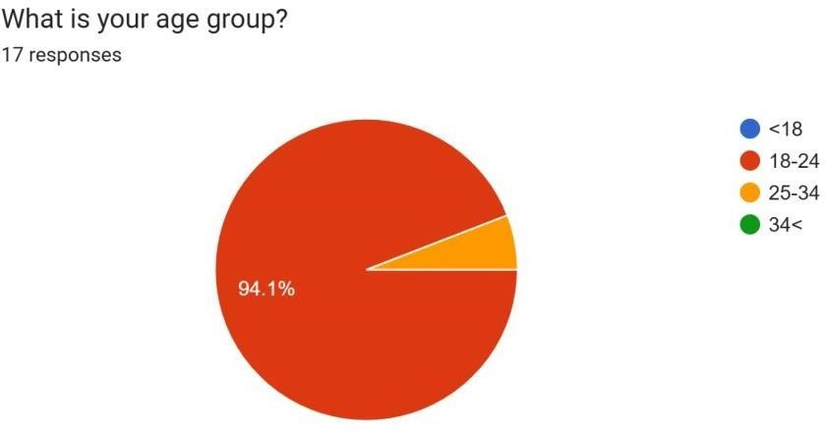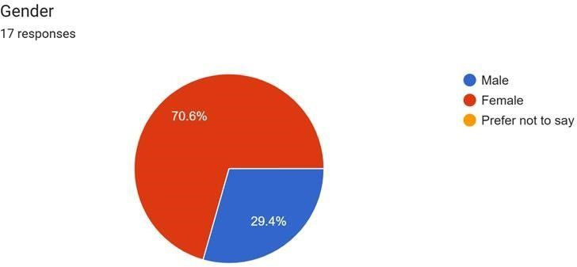

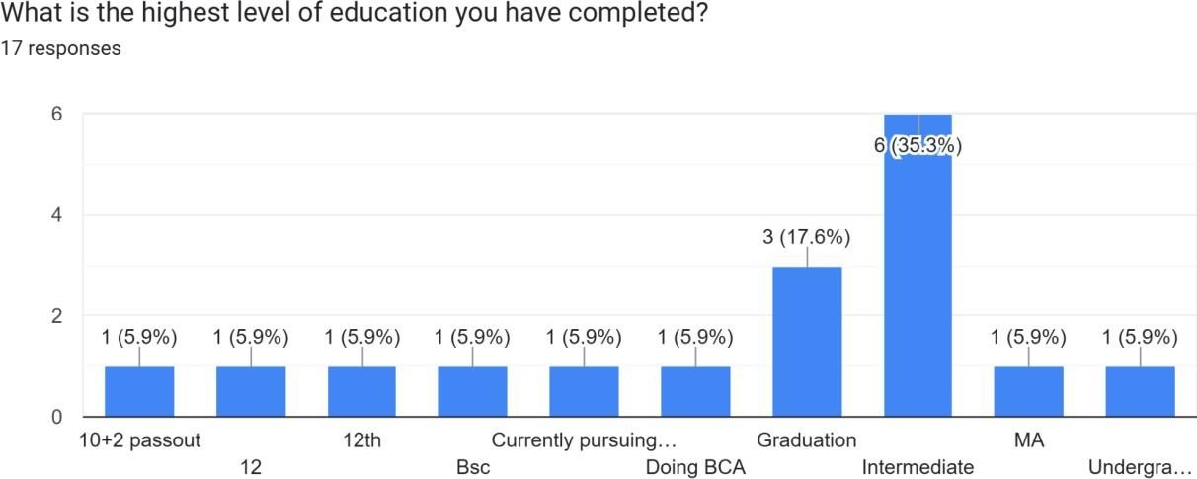

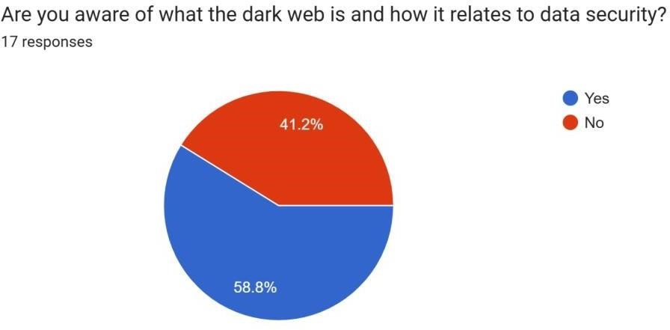

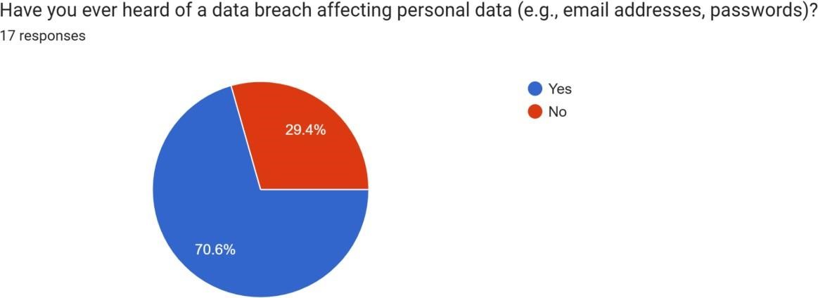

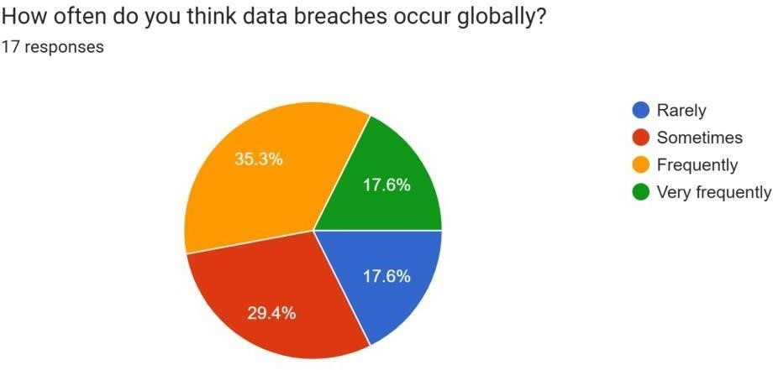

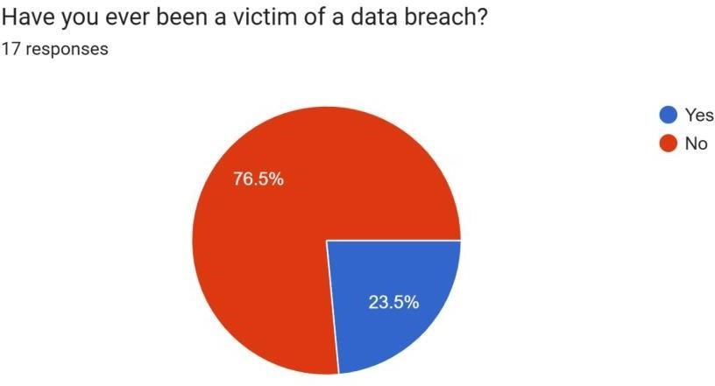

Ethical Considerations:

Ethical considerations are essential to ensure that research is conducted with integrity and respect for participants, their privacy, and their data. Research that involves the study of data exposure on the dark web and cybersecurity practices is likely to affect sensitive personal information. It is therefore essential to follow strict ethical guidelines to protect participants and maintain the validity and reliability of the study. This section describes the ethical considerations of this research, with an emphasis on participant consent, confidentiality, privacy, and data security. Informed Consent:

One of the basic ethical principles of research is to obtain informed consent from all participants. Informed consent ensures that participants are fully aware of the purpose, procedures, risks, and potential benefits of the study and that they voluntarily agree to participate. Steps to obtaining informed consent:
- Clear communication: Participants will receive a detailed explanation of the study objectives, methods, and what their participation entails. This will include information about the survey, its purpose, and the types of questions to expect.
- Voluntary participation: Participation in the study will be completely voluntary. Participants will be informed that they have the right to withdraw from the study at any time without facing negative consequences.
- Consent Form: A digital consent form will be presented at the beginning of the survey. The form will describe the purpose of the investigation, the expected duration of the investigation, the types of data collected, and the procedures in place to protect privacy. By continuing with the survey, participants will provide informed consent.
- Understanding Check: To ensure that participants fully understand the research process, they may be asked to confirm that they understand the objectives of the study and their rights. This ensures clarity and transparency before any data collection.
Confidentiality and respect for privacy Given the sensitive nature of the data being studied, particularly in relation to data exposure on the dark web and personal cybersecurity practices, it is imperative to maintain strict confidentiality and privacy throughout the research process. This includes protecting the identity of participants and the personal information they may share.

Privacy and confidentiality protection measures:
Anonymity of participants: The survey will be anonymous, meaning that no personal identifiers (such as names or contact details) will be collected. This ensures that individual responses cannot be attributed to particular participants. Participants will be asked to provide general demographic information (such as age or occupation), but will not be asked to provide identifying details.
Secure Data Storage: All survey responses will be stored securely in password- protected databases. All data to be transferred will be encrypted to prevent unauthorized access. Only the research team will have access to the data initially and access will be limited to those who need the information for analysis.
Data Use Limitation: Data collected from participants will be used only for the purposes of this study and will not be shared with outside parties. No participant data will be sold, distributed, or used for commercial purposes.
Sensitive Information: Although personal information exposed on the dark web will be investigated, participants will not be asked to disclose sensitive personal information (such as passwords, credit card numbers, or full names). The survey focuses on participants’ awareness and general experiences with data exposure rather than asking for personal or sensitive details that could compromise their security.
Data Deletion: Once the study is complete, all personally identifiable information, including any traces or metadata, will be deleted. Data retention policies will be established, ensuring that information is destroyed after a certain period of time or after the research is completed, in accordance with ethical guidelines.

Protecting Vulnerable Participants:
The study may include individuals who are more vulnerable to cybersecurity threats, including those with limited technical knowledge or data protection awareness. Special measures must be taken to ensure that these participants are not exposed to additional risks.
Measures to protect vulnerable participants:

- Ethical design of survey questions: Survey questions will be designed so as not to expose participants to additional risks. Questions about personal data breach experiences will cover general topics and will not ask for specific details such as passwords, credit card numbers or other sensitive data.
- Clear risk communication: Participants will be informed of any potential risks associated with the survey, even if the study does not directly collect or use data.
Lesson 4: Results and Discussion:

Overview of Data Leaks-

A data leak, also known as a data breach, occurs when unauthorized persons gain access to sensitive information, often with the intent to sell it, use it for malicious purposes, or simply make it publicly available. Data breaches can take many forms, from hacking individual accounts to large-scale corporate breaches involving millions of pieces of personal data. A significant portion of leaked data ends up on the dark web, where it is bought, sold, or traded by cybercriminals. These data breaches typically include sensitive information such as passwords, credit card information, social security numbers, medical records, and other personal data.
The growth of online platforms and digital services has made data breaches common, with hackers exploiting weaknesses in security systems. While some data breaches are the result of sophisticated hacking attacks, others occur due to poor security practices, such as weak passwords, unencrypted data storage, or inadequate data protection measures on the part of organizations.
Common cause of data leaks:
  - Phishing and Social Engineering Attacks.
  - Weak Passwords and Poor Authentication Practices.
  - Inadequate Security Measures by Organisations.
  - Data Sharing and Mismanagement.
  - Targeted Cyberattacks.

Case Study on Data Breaches:
▪ Case Study 1: The Equifax Data Breach (2017) The Equifax data breach, which occurred in 2017, stands as one of the largest and most high- profile data breaches in history, affecting approximately 147 million people in the United States. Equifax, one of the three major credit bureaus, suffered a breach that exposed a wide array of sensitive information, including names, social security numbers, birth dates, addresses, and in some cases, driver’s license numbers. This breach offers several key insights into how massive data leaks can occur, the types of data that are most vulnerable, and the role of the dark web in trading the stolen data.
  - Case Study 2: The Yahoo Data Breach (2013-2014) The Yahoo data breach, which occurred in 2013 and 2014 but was only publicly disclosed in 2016, is another significant case study. The breach affected all three billion Yahoo user accounts and is considered one of the largest breaches in history in terms of the number of individuals impacted. The data stolen from Yahoo included email addresses, names, telephone numbers, birthdates, and hashed passwords.
  - Case Study 3: The Facebook Data Breach (2018) The Facebook data breach, which occurred in 2018, exposed the personal data of approximately 87 million users. The breach was the result of the unauthorized harvesting of user data by the political consulting firm Cambridge Analytica, which gained access to personal information through a third-party app.
Tools for Monitoring Data Exposure- As data breaches become increasingly common and data exposure on the dark web poses growing risks to individuals and organizations, the need for effective monitoring tools has become a critical element in cybersecurity. The tools for monitoring data exposure enable users and organizations to track whether their sensitive information is being traded, sold, or exploited on the dark web. This section discusses various tools used to monitor data exposure, explores their functionalities, and evaluates their effectiveness based on survey responses and secondary research.
Importance of Monitoring Data Exposure- Monitoring data exposure is crucial in the modern digital landscape, where breaches can occur without individuals or companies being immediately aware of the compromise.
When personal or organizational data is exposed on the dark web, it can lead to identity theft, financial fraud, reputational damage, and other serious consequences. Tools that monitor data exposure can provide early warnings about the existence of sensitive information on the dark web, empowering users to take prompt action to minimize the potential damage.
Reasons why data tools are essential are-

- Early Detection of Data Leaks.
- Peace of Mind for Individuals.
- Regulatory Compliance for Organizations.
- Reputation Management.
Cybersecurity Implications:

As data breaches become more common and the risks associated with exposure on the dark web increase, cybersecurity implications have become a central concern for individuals and organizations. The increasing complexity of cyber threats, the sophistication of data theft techniques, and the evolving landscape of data exploitation on the dark web require a reassessment of current cybersecurity strategies. This section examines the broader cybersecurity implications of the findings of this study, drawing attention to key challenges, risks, and actions needed to strengthen cybersecurity defences in light of data breaches and exposure on the dark web. The Growing Threat of Data Exposure on the Dark Web-

One of the most important findings of this research is the scale and persistence of data exposure on the dark web. As previous case studies and survey data show, sensitive personal and organizational information is increasingly being traded on dark web marketplaces, forums, and clandestine networks. While many of these breaches are financially motivated, they also have far-reaching privacy, reputation and legal compliance implications. The continued trade of stolen data on the dark web exacerbates the risks of identity theft, fraud and social engineering attacks, making it crucial for individuals and organizations to adopt effective cyber security measures.
Implications for individuals: For individuals, exposing sensitive personal data on the dark web can lead to a host of privacy violations, including identity theft, account takeovers, and scams. social engineering. The survey results show that, while many people are aware of the risks, a significant number do not use surveillance tools to proactively protect themselves. This lack of action creates a loophole that hackers and fraudsters can exploit, resulting in financial loss and long-term damage to an individual's personal security.
Implications for organizations: For businesses, data breaches can be devastating, especially when they involve critical customer data such as financial information, social security numbers, and other personally identifiable information (PII). The implications for organizations go beyond financial losses; they include reputational damage, legal ramifications, and loss of consumer trust. As data is increasingly shared on the dark web, organizations must adopt proactive monitoring strategies to detect and mitigate the impact of data breaches before they are exploited in malicious attacks.
Evolving Cyber Threat Landscape-
The cybersecurity landscape is constantly evolving, and the results of this study highlight the dynamic and increasingly sophisticated nature of cyber threats. The increased availability of data on the dark web has led to the proliferation of various types of cyberattacks, including:
- Identity theft and financial fraud: The exposure of sensitive data such as credit card numbers, social security numbers, and login credentials gives attackers the tools they need to commit financial fraud. Hackers can use this information to make unauthorized purchases, open new lines of credit, or steal funds from bank accounts.
- Phishing and social engineering attacks: Stolen data, such as email addresses and passwords, are often used in phishing and social engineering attacks. Attackers use this information to pose as trusted sources, tricking victims into revealing additional personal information, downloading malicious attachments, or transferring funds.
- Ransomware attacks: Once cybercriminals gain access to sensitive data, they can also install ransomware on affected systems,encrypting files and demanding payment for their release. Data stolen in dark web breaches can be used to create targeted ransomware attacks, further increasing the financial and operational impact of cybercrime.
- Commercial espionage: Sensitive organizational data, such as intellectual property, trade secrets, and financial data, can also be sold on the dark web. This exposes companies not only to cybercriminals, but also to industrial espionage and competitors, who may seek to exploit this information for strategic purposes.
These growing threats highlight the need to protect not only from external attackers, but also to understand and mitigate the internal and external risks that result from data breaches.
Data Security Challenges-

While cybersecurity technologies continue to evolve, some challenges remain when it comes to securing data, especially in an age where large volumes of sensitive information are constantly being shared and exposed. The main challenges are:
- Inadequate data protection practices: As the Equifax and Yahoo case studies show, many organizations fail to implement adequate data protection practices. Whether due to lack of resources, awareness or careless, insufficient behaviour, weak authentication protocols.
- Complexity of Securing Data Across Multiple Platforms: Many individuals and organizations operate across multiple online platforms, including social media, cloud services, e-commerce websites, and financial institutions. Each of these platforms may have different security standards, creating a complex environment in which data protection becomes more challenging. The survey results indicated that while many users adopt basic security measures, such as strong passwords and two-factor authentication (2FA).
The role of cyber security measures in risk mitigation:
Given the increased exposure of data on the dark web and the growing complexity of cyber threats, cyber security measures must be strengthened to protect sensitive data. Effective cyber security strategies require a multi-layered approach that includes technological solutions and human vigilance.
Key cybersecurity measures that can mitigate the risks associated with data exposure include:
- Data encryption: Encrypting sensitive data, both at rest and in transit, can significantly reduce the likelihood that stolen data will be usable if exposed. Organizations must adopt end-to-end encryption for communication channels and store critical data in encrypted formats.
- Two-factor authentication (2FA): Implementing two-factor authentication (2FA) can provide an additional layer of security, making it more difficult for attackers to gain unauthorized access to accounts, even if the link of credentials is exposed. This simple measure can prevent a significant portion of attacks, especially those involving the theft of login credentials.
- Regular patches and system updates: As the Equifax breach demonstrated, patching vulnerabilities in a timely manner is essential to preventing unauthorized access. Organizations should prioritize regular software updates and vulnerability assessments to close loopholes that attackers can exploit.
- User awareness and training: Increasing user awareness of cybersecurity is one of the most effective ways to reduce the risk of data breaches. Regular training to identify phishing attempts, secure passwords, and recognize suspicious activity can significantly reduce human error and prevent breaches caused by social engineering.

Lesson 5: Conclusions and Recommendations

Conclusions
The need of protecting sensitive data in an increasingly digital environment has increased due to the dark web's emergence as a marketplace for stolen data.
Investigating the exposure of corporate and personal data on the dark web, evaluating the efficacy of existing monitoring technologies, and assessing the wider consequences for cybersecurity policies were the objectives of this study. Several important conclusions can be made in light of the survey, case studies, and literature study results.
- Frequency of Data Exposure on the Dark Web: A considerable amount of stolen data, including financial and personal information, is traded on the dark web, making data breaches a widespread problem. The long-term effects of compromised data have been demonstrated by case studies of significant data breaches, including those involving Facebook, Yahoo, and Equifax. According to the study's findings, stolen data can spread throughout dark web marketplaces after it is made public, leaving it open to abuse. A significant number of people and organizations do not know whether their data is being sold or traded on the dark web, according to the report.
- Absence of Proactive Monitoring: Many people and organizations do not actively check their data for exposure on the dark web, even though monitoring technologies are becoming more widely available. The results of the poll showed that although the majority of respondents knew that dark web monitoring services existed, very few actually made use of them. This reveals a serious weakness in cybersecurity procedures, as people and organizations do not proactively detect and reduce the dangers connected to exposed data.
- Limitations of Current Monitoring Tools: Although there are tools like credit monitoring, identity theft prevention, and dark web monitoring services, their efficacy varies. In general, these technologies work well for identifying breaches involving usernames, passwords, and email addresses, among other basic personal information. When it comes to monitoring more complicated data, such medical records, intellectual property, and confidential company information, they are constrained. Furthermore, people still struggle with problems like false positives and false negatives, particularly when it comes to separating pertinent information from irrelevant data.
- Vulnerabilities and Gaps in Cybersecurity: The inadequate cybersecurity measures taken by both people and companies emerged as a recurrent problem in the study. Weak security procedures, like insufficient encryption, bad password management, and delayed software updates, are frequently the cause of data breaches. The case studies also demonstrated the negative effects of inadequate data security procedures, namely the tardiness of patching vulnerabilities. The need for improved cybersecurity tactics and a more proactive approach to data protection is highlighted by the rising frequency of cyberattacks and the growing complexity of attackers.
- Data Privacy and Legal Implications: Organizations are facing legal issues in addition to financial and reputational risks as a result of the rise in data breaches and their subsequent exposure on the dark web.
- The Role of Cybersecurity Awareness: The survey's main conclusions were the dearth of knowledge and instruction on cybersecurity procedures. Many people and workers are unaware of the dangers of data exposure and the precautions they should take to safeguard their private and work-related data. More efficient cybersecurity education and training initiatives for both individuals and corporations are obviously needed. People are more vulnerable to social engineering, phishing, and other cybercrimes that use exposed data if they are not properly informed.
- Effect of Data Exposure on Personal and Organizational Reputation: Data breaches cause serious harm to the reputations of both individuals and companies. People may experience financial loss and mental pain as a result of privacy invasion and identity theft. Businesses may lose the trust of their customers as a result of data disclosure on the dark web, and this trust can be hard to regain. A data breach's influence on one's reputation emphasizes the importance of prevention as well as prompt response to any breaches that do occur.

Recommendations:
Several important suggestions can be made in light of the study's findings to improve cybersecurity procedures and lessen the dangers connected to data exposure on the dark web:
- Establish Thorough Data Monitoring: Using technologies to keep tabs on whether their private information is being sold or traded on the dark web should be a top priority for both individuals and corporations. Businesses should spend money on dark web monitoring services in order to identify compromised data early and take preventative action to lessen the harm. Similar to this, people should think about utilizing dark web monitoring tools and identity theft protection to keep track of the whereabouts of their personal data. Regular cybersecurity procedures should include monitoring data exposure on the dark web.
- Increase Cybersecurity Awareness and Training: To better inform people and staff about the dangers of data exposure, the significance of individual and organizational security, and the best ways to protect sensitive data, cybersecurity training programs should be extended. Regular security awareness campaigns and training sessions covering subjects like phishing attacks, password hygiene, and secure data handling should be held by organizations.
- Strengthen Data Encryption and Authentication: A key element of every organization's cybersecurity plan should be the encryption of sensitive data, both in transit and at rest. Strong encryption makes sure that even in the event that data is compromised, unauthorized people cannot access or use it. Furthermore, even in the event that login credentials are hijacked, the use of two-factor authentication (2FA) can strengthen online accounts and systems by making it more difficult for hackers to obtain illegal access.
- Adopt Proactive Incident Response Plans: Businesses must to create and carry out proactive plans for incident response and recovery. These strategies must to specify precisely how to identify, evaluate, and react to data breaches, including informing impacted parties and implementing remedial measures. To make sure that employees are equipped to react quickly and efficiently to data breaches, regular drills should be held.
- Enhance Data Retention and Disposal Procedures: To reduce the quantity of sensitive data that is kept needlessly, organizations should implement stronger data retention and disposal guidelines. To make sure that only essential data is kept and that outdated or unnecessary data is safely erased, audits should be conducted on a regular basis. In the case of a breach, this lessens the possibility of data disclosure.
- Put in Place Stronger Regulatory Compliance Measures: Organizations must put in place mechanisms to track data exposure, disclose breaches, and safeguard personal information in order to comply with data protection laws like the CCPA, GDPR, and others. In addition to being required by law, following these rules is essential to preserving public and customer trust.
- Cooperation with Law Enforcement and Cybersecurity Communities: To monitor the release of stolen data on the dark web, enterprises should work with cybersecurity and law enforcement groups. To better battle the sale and misuse of stolen data, the cybersecurity industry may collaborate to detect cybercriminals and share threat intelligence.
- Use Multi-Layer Security Techniques: Sensitive information should be protected using a multi-layered security technique. Using firewalls, intrusion detection systems, endpoint protection, and frequent software upgrades are some ways to guarantee that vulnerabilities are fixed before hackers can take advantage of them.
- Pay Attention to Long-Term Reputation Management: Following a data breach, businesses should concentrate on restoring customer confidence by being open and honest about the occurrence and the actions being done to lessen the harm. Strategies for public communication should highlight the company's dedication to enhancing security and protecting client information.
Final Thoughts:
A serious and expanding risk to people and businesses is data vulnerability on the dark web. People may safeguard their personal information by taking a proactive and allencompassing approach to cybersecurity, and businesses can reduce the likelihood of data breaches and lessen the harm that results from exposure. Protecting sensitive data in an increasingly digital world requires increased awareness, the use of monitoring technologies, robust data protection mechanisms, and a dedication to cybersecurity best practices. In the end, constant attention to detail, teamwork, and a robust security culture at all levels are the keys to reducing the dangers of data exposure.
Lesson 6: Reference:

- Anderson, R. (2020). Security Engineering: A Guide to Building Dependable Distributed Systems (3rd ed.). Wiley.
- Barrett, R. (2019). The Dark Web: Exploring the Hidden Internet. Oxford University Press.
- Cheng, M., & O’Neill, J. (2022). "The Dark Web and Its Impact on
Cybersecurity."
Journal of Cybersecurity and Information Assurance, 15(4), 45-63.
- Hernandez, A. (2018). Data Breaches: Causes, Consequences, and Prevention Strategies. Pearson.
- Krebs, B. (2019). Spam Nation: The Inside Story of Organized Cybercrime from Global Epidemic to Your Front Door. Sourcebooks.
- McMillan, R. (2020). "Cybersecurity Challenges in the Age of the Dark Web." IEEE Security & Privacy, 18(3), 34-41.
- Miller, R., & Sykes, P. (2021). "Dark Web Data Trading and the Cybersecurity Implications for Organizations." International Journal of Information Security, 29(5), 102118.
- Ralph, D. (2021). "Dark Web Monitoring: A Critical Component of Modern Cybersecurity." Journal of Cybersecurity & Data Protection, 10(2), 97-115.
- Reid, R. (2020). "The Role of Encryption in Protecting Data in the Digital
Age."
International Journal of Cybersecurity Technology, 12(1), 89-102.
- Sharma, M., & Pandey, P. (2018). "The Rise of the Dark Web: Risks and Strategies for Cybersecurity." Journal of Information Technology, 21(3), 55-71.
- Smith, T., & Howell, D. (2021). Digital Privacy: Protecting Personal Data from Cyber Threats. Routledge.
- Tung, S., & Tan, S. (2022). "Cybersecurity Frameworks for Data Protection: Responding to Dark Web Exposure." Cybersecurity Review, 14(6), 22-38.
- Williams, H. (2021). "Dark Web Data and Its Impact on Privacy Laws." Journal of Law and Technology, 18(2), 124-140.
- Zhou, L., & Wang, Y. (2019). "Exploring the Dark Web: An Overview of Risks and Security Solutions." Journal of Cybersecurity and Privacy, 3(4), 211-226.

Appendix
Case Study Details

The following case studies were analyzed in this research to examine the real- world implications of data breaches and their subsequent exposure on the dark web: Case Study 1: Equifax Data Breach (2017)

- Incident: A data breach at Equifax, one of the biggest credit reporting companies, in 2017 resulted in the exposure of private data, including the addresses, birth dates, Social Security numbers, and driver's license numbers of roughly 147 million individuals.
- Impact: Equifax suffered long-term harm to its reputation in addition to monetary losses as a result of the hack. Shortly after the breach was identified, the stolen data surfaced on the dark web.
- Reaction: Equifax provided impacted individuals with free credit monitoring; however, the hack exposed serious weaknesses in cybersecurity procedures, such as the neglect to address a known vulnerability in the Apache Struts software.
- Significance: This case study illustrates the extent of personal data exposure and the urgent necessity of proactive dark web activity monitoring in order to detect compromised data early.
Case Study 2: Yahoo Data Breach (2013-2014)

- Incident: Over 3 billion Yahoo accounts were hacked in a significant data breach. Over the course of several years, email addresses, passwords, and security questions were made public due to the breach.
- Impact: Yahoo suffered severe financial and reputational repercussions from the hack, particularly following its acquisition by Verizon. The stolen information was used in later cybercrimes after being discovered circulating on the dark web.
- Reaction: Following the disclosure of the hack, Yahoo provided password resets to impacted users and put in place further security measures.
- Significance: This instance emphasizes how crucial it is to keep an eye out for stolen data on the dark web and how businesses must alert users as soon as they discover a breach.
Tools for Data Monitoring
A list of suggested tools and services for keeping an eye on the exposure of organizational and personal data on the dark web is provided below:
- Was I pwned out? A free web tool that lets users see if any of their personal data, including email addresses, has been compromised. Additionally, the service notifies users when new breaches are discovered.
- SpyCloud A dark web surveillance service that keeps track of passwords,
emails, and other private information that has been taken. SpyCloud warns users of possible dangers and finds compromised accounts using automated technologies.
- IdentityForce A complete identity protection solution with a toolkit that includes dark web monitoring. If personal information is discovered on the dark web, it instantly notifies users.
- Digital Shadows A cybersecurity firm that provides enterprises with dark web monitoring. To find exposed organizational data, Digital Shadows keeps an eye on forums, chat rooms, and dark web marketplaces.
- RiskIQ A cybersecurity platform that offers dark web surveillance in addition to other services. Tracking compromised corporate data on the dark web and warning companies about possible breaches are the main goals of RiskIQ.

Glossary of Terms
- The term "Dark Web" refers to a portion of the internet that is not indexed by conventional search engines and is frequently connected to illicit activity, such as the selling of stolen data.
- Data breach: An event in which unapproved parties obtain private information, frequently leading to the disclosure of financial or personal data.
- Dark Web Monitoring: Programs and services that keep tabs on whether private or corporate information is present on forums, dark web markets, and other hidden websites.
- Encryption: A procedure that turns data into a code to guard against unwanted access. Phishing is a type of cyberattack where attackers use phony emails or websites to mislead victims into disclosing private information, like credit card numbers or passwords.

